OVERALL CHECK LIST
Website Testing Scenarios for QMS.AIVOA.AI

1. Functional Testing WORKS WELL
Header / Navigation Testing
- Verify logo redirects to homepage. OK
- Verify all menu links work: DONE
  - Why AI? OK
  - Platform OK
  - How It Works OK
  - Modules OK
  - Case Studies OK
  - Pricing OK
  - Contact Us OK
- Verify “Book a Demo” button redirects correctly. OK

2. Button Testing NEED IMPROVEMENT
Buttons
Test:
- “Book a Free Demo” OK
- “Watch Demo” OK
Validated:
- Clickability OK
- Links Redirection Defect
(Youtube & Twitter - Links error 404)

3. Form Testing NEED IMPROVEMENT
Forms exist on demo pages:
Input Validation
- Empty submission OK
- Invalid email format Defect
- Name Text field Defect
- Number text field Defect
- Long input values Defect
- Mandatory field validation OK
Functional Checks
- Form submission success message OK
- Duplicate submission prevention Defect

4. UI/UX Testing ACCEPTABLE
Layout Validation OK
- Alignment consistency OK
- Proper spacing/padding OK
- Font consistency OK
- Text overlap issues OK
- Image alignment OK
5. Responsive Testing ACCEPTABLE
Test on:
- Mobile OK
- Desktop OK

6. Cross Browser Compatibility Testing Acceptable
Test on:
- Chrome OK
- Firefox OK
- Edge OK
7. Performance Testing ACCEPTABLE
Check
- Page load speed OK

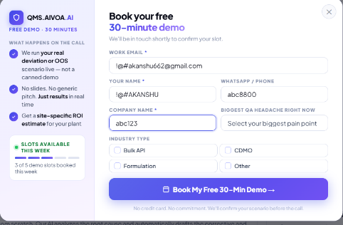
--------------------------------DEECT SCREEN-SHOTS----------------------------------------------

Work Email | !@#akanshu662@gmail.com
Your name | !@#AKANSHU
Phone | abc8800
Company Name | abc123
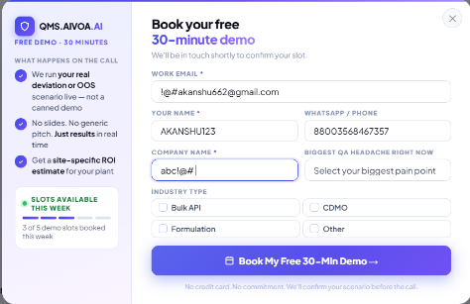
-----------------------------------------------------------------------------------------------------

Work Email | !@#akanshu662@gmail.com
Your name | AKANSHU123
Phone | 88003568467357
Company Name | abc!@#
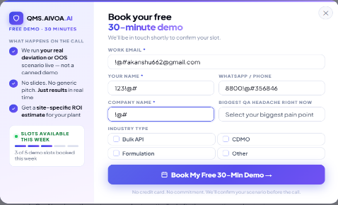
-----------------------------------------------------------------------------------------------------

Work Email | !@#akanshu662@gmail.com
Your name | 123!@#
Phone | 8800!@#356846
Company Name | !@#
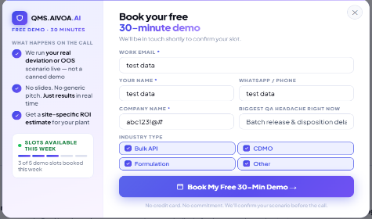
-----------------------------------------------------------------------------------------------------

Work Email | Test Data
Your name | Test Data
Phone | Test Data
Company Name | abc123!@#
-----------------------------------------------------------------------------------------------------
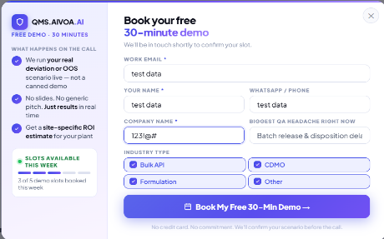
Work Email | Test Data
Your name | Test Data
Phone | Test Data
Company Name | 123!@#

----------------------------------------------------ERROR LINKS-----------------------------------------
Error in Footer Links
Youtube ~ 404 error

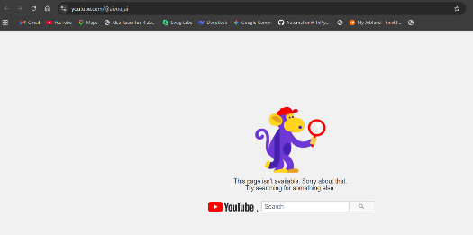
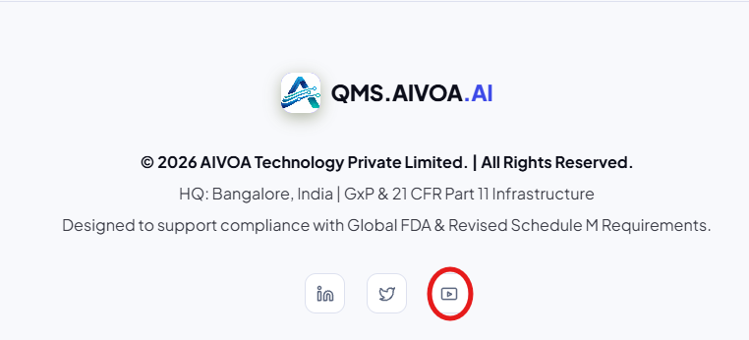
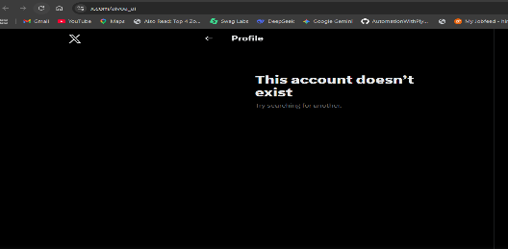
Twitter ~ account does not exist
